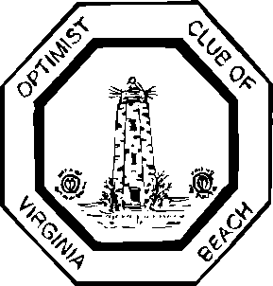

OPTIMIST CLUB OF VIRGINIA BEACH
“Friend of Youth”
Post Office Box 9310, Virginia Beach, VA 23450
(757) 486-4650
Oratorical Contest
When: Thursday, March 13, 2014, 7:00 PM
Where: Bryant and Stratton College, 301 Centre Pointe Drive, Virginia Beach
Prizes: Medallions, Certificates and College Scholarships
Topic: "How My Passions Impact the World"
Contact: Jim McClane, Optimist Club of Virginia Beach Oratorical Contest Chair, 647-5217
The Optimist Club of Virginia Beach is encouraging area students to speak their minds for five minutes about the topic “How My Passions Impact the World” as part of the Optimist International Oratorical Contest for the 2013-2014 school year. Optimist clubs have organized these annual contests since 1928.
Professional and prominent members of the local community will assist the Optimist Club judging the local students' speeches based on content and presentation to determine the top winners. Winners will receive certificates, medallions and the winning speeches will be sent to the zone level, and possibly the district level for the opportunity to win college scholarships.
Students under the age of 19, who have not yet graduated from high school or the equivalent, are eligible to participate. A printed copy of the speech and a copy of birth certificate or passport must be presented at the contest prior to speaking.
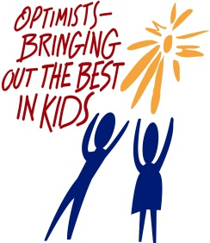
Optimist International is one of the world's largest service club organizations with 93,000 adult and youth members in 3,200 clubs in the United States, Canada, the Caribbean and Mexico and throughout the world. The Optimist Oratorical contest is one of the organization's most popular programs, with more than 2,000 clubs participating annually.

